Listeners in Windchill

SET STATE Listener Example-1:

Description: The following example adds a listener on set State event, it blocks set state on WTDocument if it's not linked to a WTpart( by reference link)

Procedure:

- Create and implement the Listener Adapter, it must extend wt.services.ServiceEventListenerAdapter and must perform the required business logic implementing the notifyVetoableEvent method.
- After creating the class first, we need to create a constructor as shown below.
- Override “notifyVetoableEvent” method with the required business logic
- Implement the handleWTDocumentSetState method to prevent the set state when the WTDocument is not associated to a WTPart with a Reference Link
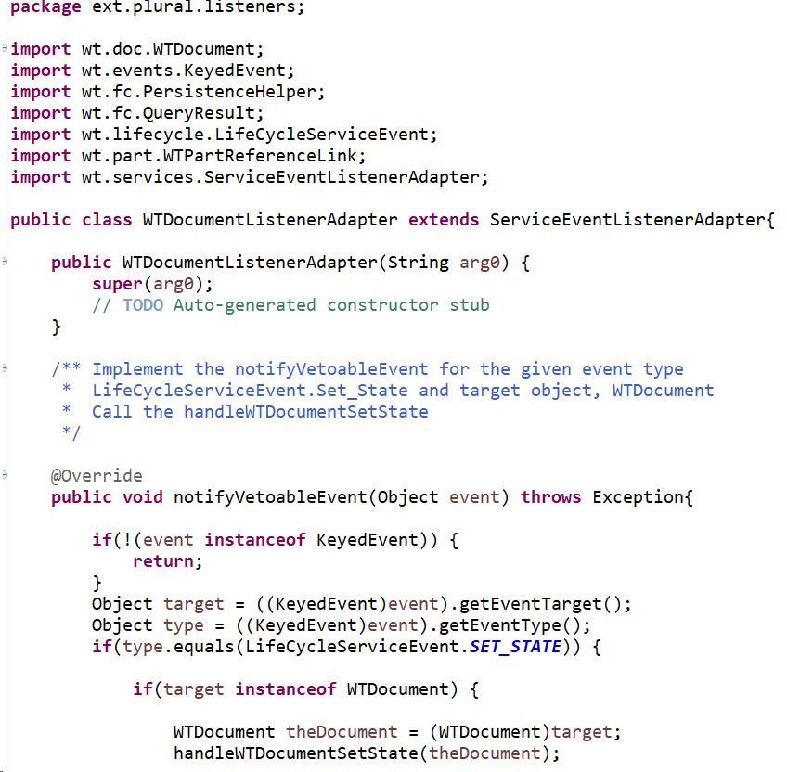

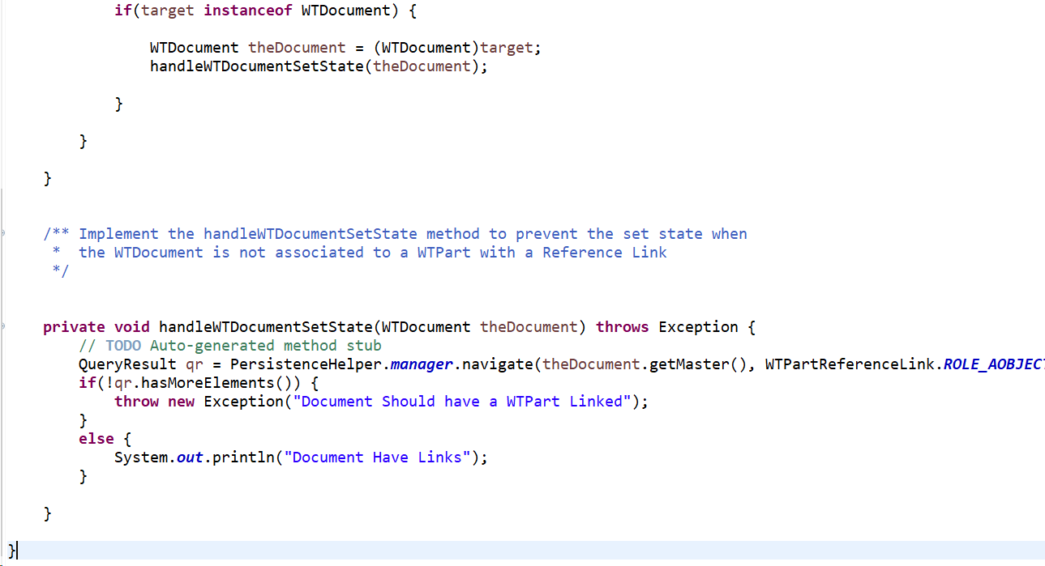

- Create the Listener as shown below which is an Interface.

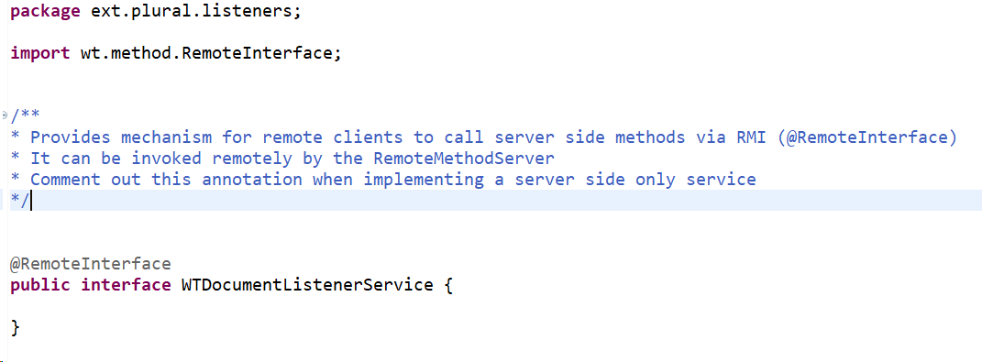

- Implement the Standard Listener, it must extend wt.services.StandardManager and must implement the above interface. In the startup process, it will register the ListenerAdapter against the required event Set_State.
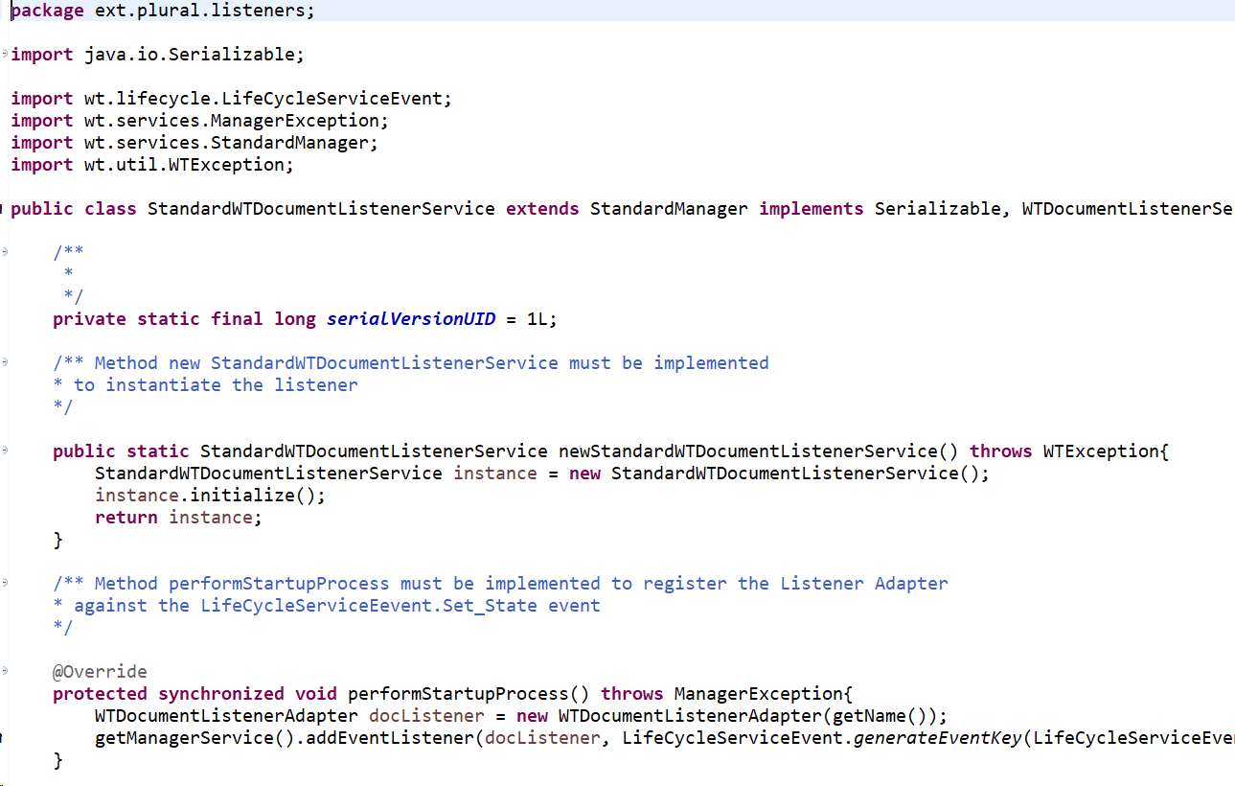

- create two files myservice.xconf and myservice-wt.properties.xconf as shown below.
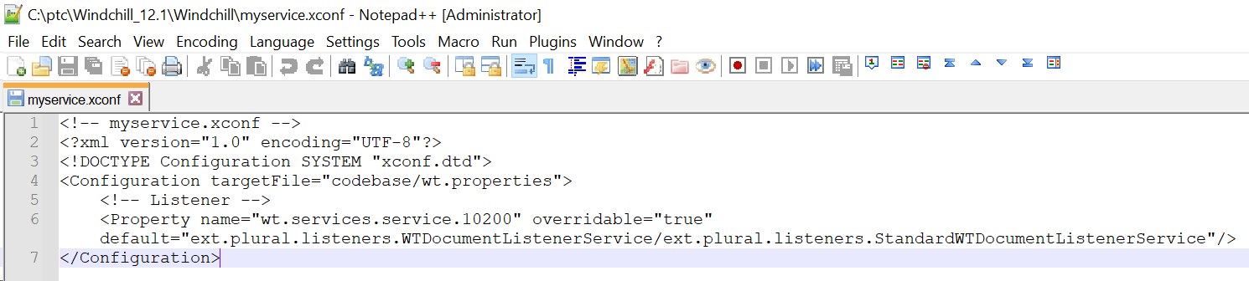

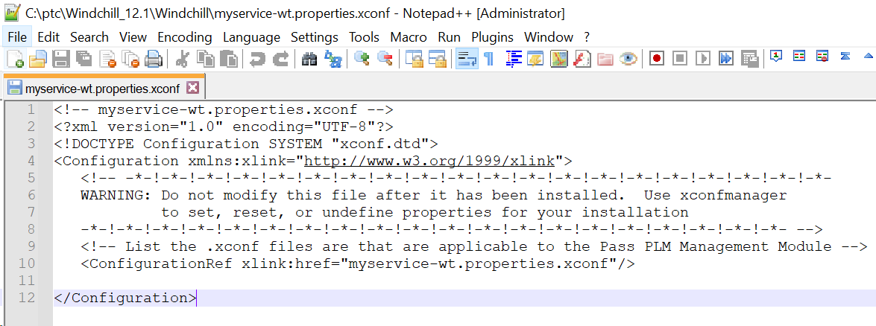

- Execute the command mentioned in shell and restart Windchill.
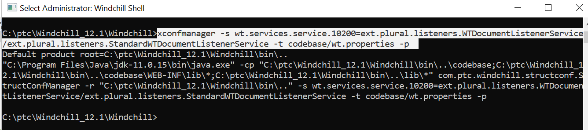

- Listener is going to be registered in wt.properties file.
- Test it by creating a new Document of type Reference, perform set state to Released, Windchill must give an error. Now, create a WTPart, link this Document as Reference Document and check-in, redo set state, it must complete.

Reference Article: Article - CS213788 - How to create a Listener in Windchill PLM (ptc.com)

REVISE Listener Example-2:

Description: The following example adds a listener on Revise event, it blocks revising a WTPart when it is not at “Released” state.

Procedure:

- Create and implement the Listener Adapter, it must extend wt.services.ServiceEventListenerAdapter and must perform the required business logic implementing the notifyVetoableEvent method.
- After creating the class first, we need to create a constructor as shown below.
- Override “notifyVetoableEvent” method with the required business logic
- Implement the handleWTPartRevision method to prevent revising a WTPart when it is not at “Released” state.
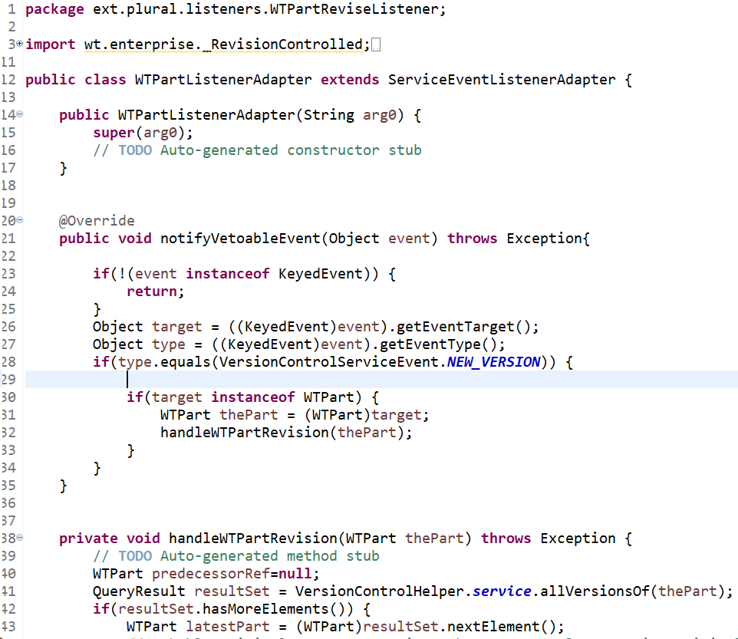
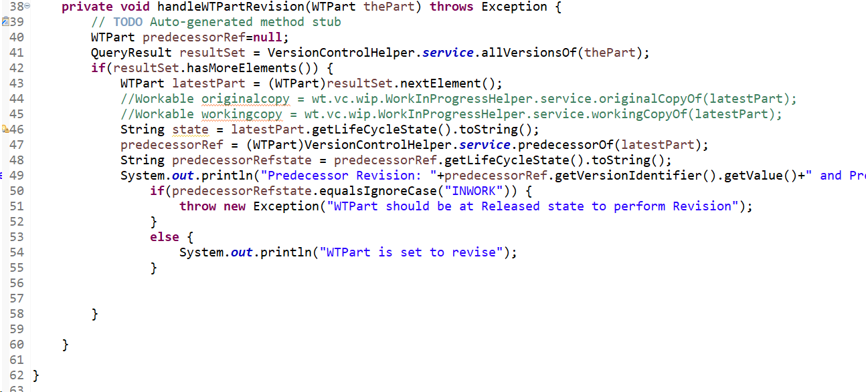

- Create the Listener as shown below which is an Interface.

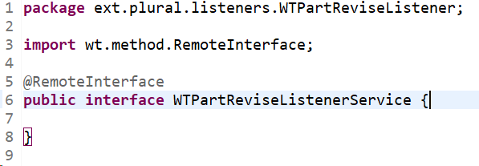

- Implement the Standard Listener, it must extend wt.services.StandardManager and must implement the above interface. In the startup process, it will register the ListenerAdapter against the required event NEW_VERSION.
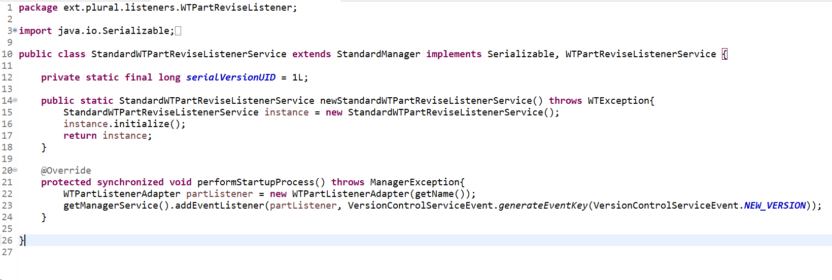

- create two files myservice.xconf and myservice-wt.properties.xconf as shown below (Just to track the custom listeners list we are maintaining this file).
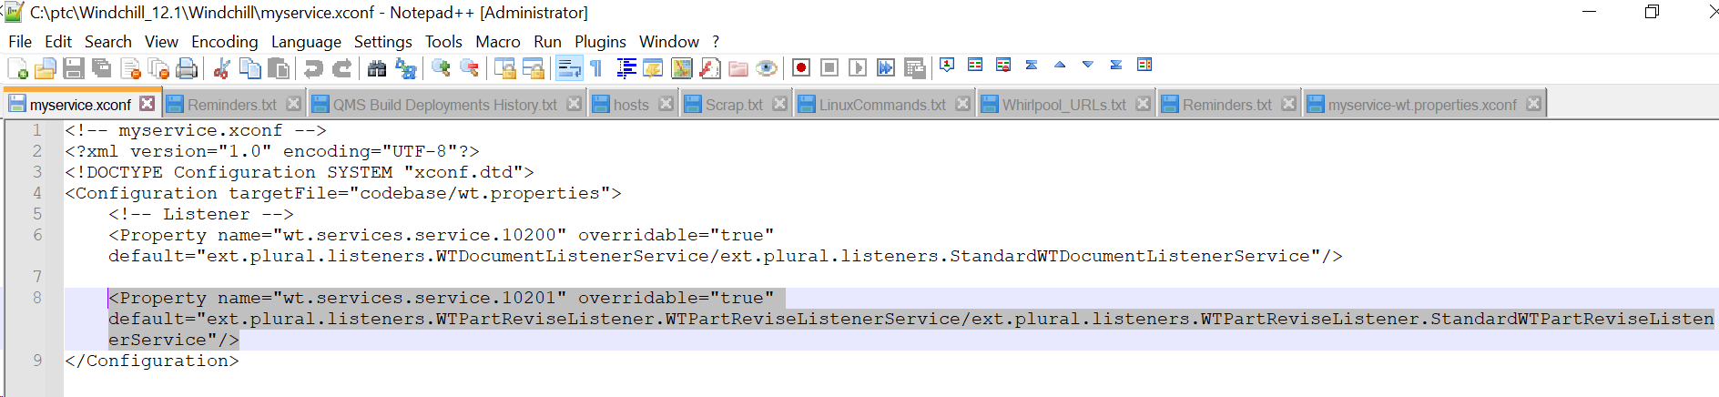

- Execute the command mentioned in shell and restart Windchill.
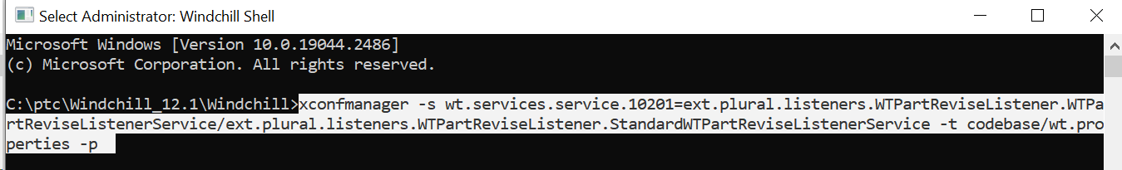

- Listener is going to be registered in wt.properties file.
- Test it by revising a WTPart which is at “In Work” state and it will throw the defined error.

Windchill PLM - Events and Listeners

Article - CS361423 - [Knowledge Hub] Windchill PLM - Events and Listeners (ptc.com)

